7)Display the video, in slow motion and in fast motion. operations on the captured video
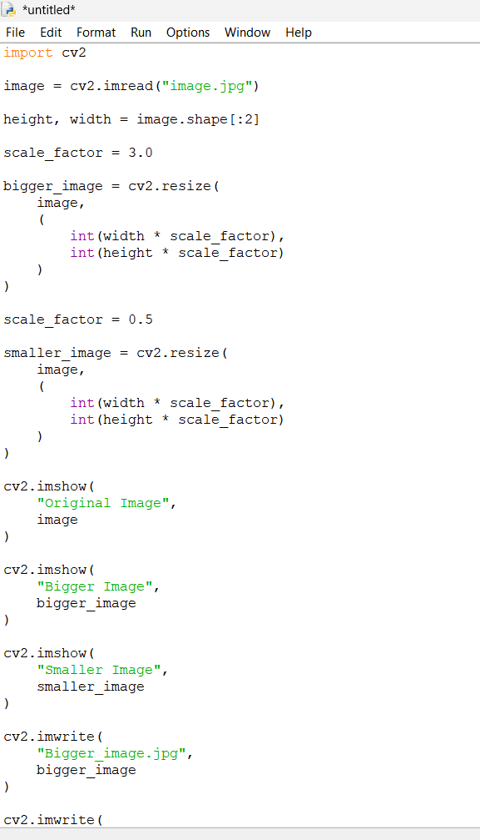

Output
